Honors Physics – Circular Motion and Gravitation
Mr. Young
Problem Set 2

1. When is work being done?
a) When potential energy is converted to kinetic energy.
b) When kinetic energy is converted to potential energy.
c) When an applied force increases either potential or kinetic energy.
d) All of the above.
2. According to Newton’s Law of Gravitation which of the following is true.
a) The force of gravitational attraction between two bodies is inversely proportional to the product of the two bodies masses.
b) The force of gravitational attraction between two bodies is inversely proportional to the distance between the two bodies.
c) The force of gravitational attraction between two bodies is directly proportional to the sum of the two bodies masses.
d) The force of gravitational attraction between two bodies is inversely proportional to the square of the distance between the two bodies.
3. Newton’s second law of motion states that:
a) The acceleration experienced by a body is directly proportional to the force applied and inversely proportional to its mass.
b) A body at rest will remain at rest and a body in motion will remain in motion unless acted on by an unbalanced force.
c) When body A applies a force to body B, body B exerts a force on body A that is equal in magnitude and opposite in direction.
d) The acceleration experienced by a body is inversely proportional to the force applied and directly proportional to its mass.
4. The mass of object A is 3 times as great as the mass of object B. A force F is applied to both object A and B. Which statement best describes the acceleration experience by objects A and B?
a) They will both experience the same acceleration because an object’s acceleration is directly proportional to the force applied to it.
b) The answer cannot be determined with the information given. The applied force and the exact mass of each object must be known in order to calculate the acceleration resulting from the applied force.
c) The acceleration of object B will be three times as great as the acceleration of object A.
d) The acceleration of object A will be three times as great as the acceleration of object B.

5. Potential energy E_{p} of object A is converted into kinetic energy E_{k}. You know the magnitude of E_{p}. What is the magnitude of E_{k}?
a) Cannot be determined. You must know object A’s mass and velocity to calculate its kinetic energy by the formula E_{k} = ½ mv².
b) E_{k} will have the same magnitude as E_{p}.
c) E_{k} will have the opposite magnitude of E_{p}.
d) E_{k} is equal to E_{p} divided by the mass of object A.
6. The force of attraction between a star and an orbiting planet is equivalent to what part of the planet’s orbital motion?
a) The centrifugal force exerted on the planet.
b) The radial velocity of the planet.
c) The centripetal force exerted on the planet.
d) The centripetal acceleration experienced by the planet.
7. An object has a mass of 13 kg.
a) What force must be applied to accelerate it at 5m/s²?
b) What would be the acceleration if a 26N force were applied?
8. M_{moon} = 7.35x10²² kg
m_{earth} = 5.97x10²⁴ kg
r_{e,m} = 3.8x10⁸m
G = 6.67x10⁻¹¹Nm²/kg²
a) Calculate the gravitational force on the Moon by the Earth.
b) What is the gravitational force on the Earth by the Moon?

- Consider the motion of this pendulum. h = 2m
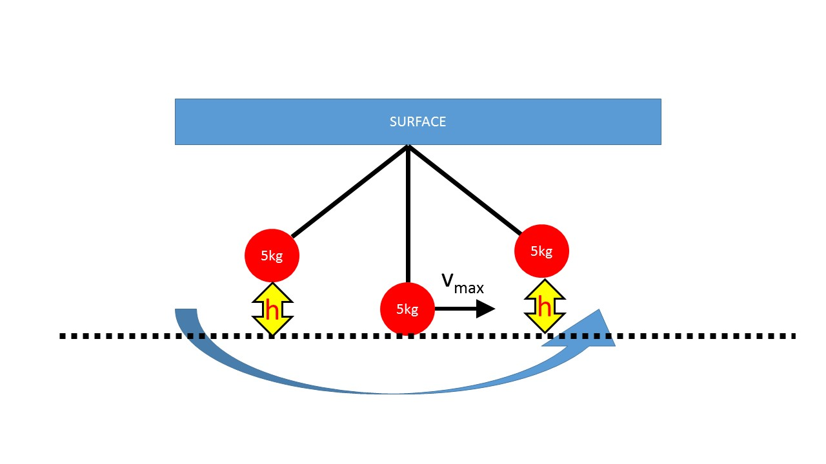
- Calculate the maximum gravitational potential energy (GPE_{max}).

- Calculate the maximum velocity V_{max}.

